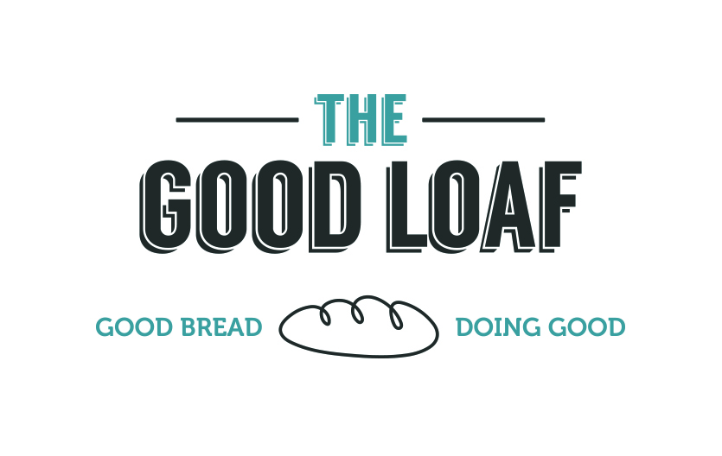
Application/Referral Form

Email to: info@thegoodloaf.co.uk
Female.oocd@thegoodloaf.cjsm.net
(telephone 01604 824084)

Participant
Title and Full Name:

Preferred Name:

Date of Birth:
Address:

Post Code:
Email Address:

Telephone Number/s:
Emergency Contact/Next of Kin:
(name, relationship and contact details)

Reason for referral: |  | VOLUNTEERING  LEARNING HUB COURSES (please specify which course(s)  STUDENT PLACEMENT  OTHER  (tick as approriate)
Further information

Current agencies involved in support (if applicable) Please include contact name and number
Agency 1
(Name and Tel):

Agency 2
(Name and Tel):

Offence (if applicable)

Do you have any Diabilities?
(please expand and detail assistance you may require)

SUPPORT NEEDS
Do you have any mental health issues? |  |  | Yes No (delete as appropriate)
If yes please give details:

Do you have any physical health issues? |  |  | Yes No (delete as appropriate)
If yes please give details:

Any current, relevant medication (details): |  |  | Yes No (delete as appropriate)
If yes please give details:

Do you have any learning difficulties? |  |  | Yes No (delete as appropriate)
If yes please give details:

Do you have any additional support needs? |  |  | Yes No (delete as appropriate)
If yes please give details:

Please note that we may require additional information from yourself or other parties. If you have any objections to this please note them here:
Ethnicity: |  |  | White black Asian mixed heritage chinese other
Gender: |  |  | Female male trans other
Nationality: |  |  | British national foreign national
Relationship Status: |  |  | Married cohabiting separated divorced widowed single  in a relationship
Religion:

Sexual orientation: |  |  | Heterosexual Lesbian Bisexual Other
Risk assessment (To be completed by referring agency)
At risk of offending: |  |  | Yes No (delete as appropriate)
If yes please give details:

Been in prison |  |  | Yes No (delete as appropriate)
Been on a probation order |  |  | Yes No (delete as appropriate)
Family member is an offender / ex-offender: |  |  | Yes No (delete as appropriate)
If yes please give details:

Have you ever been a risk to…

Children |  |  | Yes No (delete as appropriate)
The public |  |  | Yes No (delete as appropriate)
Known adults |  |  | Yes No (delete as appropriate)
Professionals |  |  | Yes No (delete as appropriate)
Agreement
I understand signing up for any courses/volunteering at The Good Loaf means that I will attend the agreed sessions on time.

Signed:  (client) |  |  |  | Date:
Referrer’s Name:  (if applicable) |  |  |  | Date:
Organisation:

Referrer’s Mobile No:
Referrer’s email:
Referrer’s comments:

Client Confidentiality Statement

Any information passed to any representative of the project may be shared with other representatives ONLY on a 'need to know' basis.

Delivery partners include: The Good Loaf, Aimhigher and Neighbourhood Learning

All information will be held securely in line with the terms of the General Data Protection Regulations (GDPR). Care is taken to ensure that discussions, conversations, and telephone calls relating to confidential matters cannot be overheard. Identifying details are only shared when necessary.

Issues relating to crime, endangering themselves or another person, or to the safety and well-being of children must be reported to external agencies.

Confidentiality Agreement

I have read or had read to me the confidentiality statement. I understand that information about me may be shared within the project. I understand that my information may be shared with other external agencies if there is a risk of harm to myself or others, or if I am involved in criminal activity.

Signature…………………………………… Date……………………….

Full Name…………………………………………………………………………………………………….

GDPR Agreement

The details that you provide us with will be used to send you correspondence specific to the mailing list that you are signing up to.

We will only send you communication as long as we have your consent to do so. If you wish to stop receiving correspondence from us, you will be able to unsubscribe at any time by contacting info@thegoodloaf.co.uk.

To read our full privacy policy please request a copy from any member of staff.

If you agree to the above statement please indicate below the ways in which you are happy for us to contact you.

Email/sms/phonecall/letter/mail merge (delete as appropriate)

Signature…………………………………… Date……………………….

Optional

I agree that Delivery Partners may speak to my family & friends/ other agencies (delete as appropriate)

Signature…………………………………… Date……………………….

